|  |  |
| --- | --- |
|  | **Learning From Multi-agency Audits**  Young People at Risk of Exploitation  **This briefing summarises the findings and learning outcomes form a recent SAB multi-agency audit.**  **Staff in all SAB partner agencies that work with adults with care and support needs are encouraged to read the briefing and discuss it in their team meetings.**  **For further information in relation to this briefing or if you would like a copy of the full audit report, contact George Coleby, Quality Assurance & Learning Development Officer** [**george.coleby@eastsussex.gov.uk**](mailto:george.coleby@eastsussex.gov.uk) **or 07712 236676** |

In 2019 the Performance, Quality and Audit (PQA) Subgroup conducted a multi-agency audit in relation to Young People at Risk of Exploitation, on behalf of the East Sussex Safeguarding Adults Board (SAB)

Thepurpose of the audit was: ‘To assess the effectiveness of multi-agency safeguarding responses to young people (aged 16-25) at risk of exploitation’. The audit sought specifically to evaluate and assess:

* Timely identification of exploitation risk
* The effectiveness of  multi-agency working to reduce risk
* Making Safeguarding Personal and Empowerment
* How potential barriers to engagement were recognised and addressed
* Information sharing between Children’s and Adult Services

The audit group comprised representatives from East Sussex Adult Social Care & Health (ASCH), Children’s Services, Sussex Police, East Sussex Clinical Commissioning Groups (CCGs), Sussex Partnership NHS Foundation Trust (SPFT), East Sussex Healthcare NHS Trust (ESHT), National Probation Service, Change, Grow, Live (CGL) and Salvation Army Housing Association (SAHA).

The audit involved a benchmarking exercise which involved a questionnaire sent to all agencies to identify gaps in service provision in relation to young people at risk of exploitation. This was followed by a detailed audit of five cases where safeguarding concerns had been raised in the period 1st April 2018 - 31st March 2019, and there had been concerns about exploitation including sexual exploitation and criminal exploitation such as cuckooing, county drug lines or modern slavery. All of the individuals involved were aged 16-25 and two were under 18 at the time of the safeguarding concern. A summary of the cases audited is shown below. The names have been changed to protect the confidentiality of the individuals.

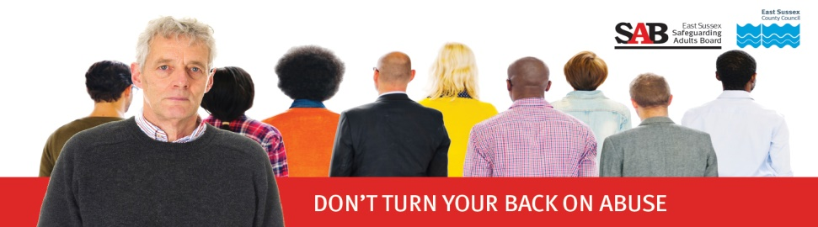

**The audit findings and recommendations**

The audit identified a number of strengths and examples of good practice and some areas for improvement and development. The main findings are summarised below.

|  |  |
| --- | --- |
| **What was done well** | **What could be improved and areas for development** |
| * Effective multi-agency working and information sharing in several cases, particularly evident between Children’s Services, Youth Offending Team (YOT) and the Under 19 Substance Misuse Service (U19 SMS). | * The effectiveness of current processes to identify, manage and communicate risks for young people approaching their eighteenth birthday. |
| * Appropriate and timely safeguarding referrals by Sussex Police and SAHA. | * Recording of safeguarding concerns and Section 42 enquiries by Adult Social Care & Health (ASCH). This issue was identified in a previous audit and actions are in place to address this. |
| * Application of a Making Safeguarding Personal approach in several cases. | * The audit raised the need for awareness-raising around recognising the different forms of exploitation that come under the abuse type of modern slavery, which can include cuckooing and county lines. |
| * Recognition of the importance of understanding the impact of childhood trauma in later life and of the importance of using trauma-informed practice. | * There is a need for a greater understanding about how involvement in substance misuse and drug debt can increase risks of exploitation. |
| * Good professional curiosity demonstrated in many cases including exploration of a range of options and linking in with specialist services and advocacy support. | * Within hospital settings, consideration to be given to developing effective systems for flags/ alerts regarding exploitation risk. |
| * A number of cases reflected appropriate consideration and application of the Care Act and Mental Capacity Act principles. | * Multi-agency involvement in developing safeguarding plans could be improved. The cases reviewed reflected that ASCH often do not clearly document which agencies they have informed or shared the safeguarding plan with. |
| * Proactive support from a GP in conducting annual health checks for patients with learning disabilities to help identify risks. | * There was a lack of effective information sharing and communication across key agencies in a number of cases. Communication with Primary Care was particularly lacking. |
| The audit group has developed an action plan to address the areas for improvement and development. Progress in implementing the action plan will be monitored by the PQA Subgroup. | * The specific cases in this audit have highlighted the importance of practitioners having knowledge about trauma-informed practice, and how this can be used to support people to build resilience. |

**County Lines and Cuckooing**

Cuckooing is a crime in which drug dealers take over the home of a vulnerable person to use it as a base for criminal activity. Organised criminal groups target adults with care and support needs, and the level of coercion and control involved often leaves the victims with little choice but to co-operate with the perpetrators. This can include victims being frightened of contacting the police for fear of being suspected of involvement in drug dealing or being identified as a member of the group, which would result in their eviction from the property.

Victims of cuckooing may be subject to a variety of types of abuse as defined in the Care Act 2014, and may include modern slavery.

Victims who are at risk from county lines and / or cuckooing are often lonely, isolated, drug users and known to the police.

You can find out more about County Lines [here](https://assets.publishing.service.gov.uk/government/uploads/system/uploads/attachment_data/file/741194/HOCountyLinesGuidanceSept2018.pdf)

Our [SAB briefing](https://www.eastsussexsab.org.uk/learning-briefings/modern-slavery-briefing/) following a multi-agency audit in relation to Modern Slavery also includes more helpful guidance and resources.

Young people who have substance misuse problems may get into debt and so become more vulnerable to exploitation from dealers.

**Recognising the signs:**

Indicators of county lines and cuckooing may include:

* Multi-occupancy or social housing property used for drug dealing.
* Substance misuse and / or drug paraphernalia.
* Increase in visitors and cars to a house or flat.
* New vehicles outside the property, and / or frequent use of taxis or hire cars.
* Professionals visiting may be aware of new unidentified persons in the property, regularly changing residents and an increase in anti-social behaviour in and around the property.
* Unexplained, sometimes unaffordable, new things (e.g. clothes, jewellery, cars etc.).
* Property may be sparse, lack any valuable possessions, and fall into a state of disrepair.
* Change in resident’s mood and / or demeanour (e.g. secretive, withdrawn, aggressive, emotional).
* Young person is not engaging with support services.
* Unexplained injuries.

**It is important to remember that young adults with a learning disability or mental health support needs are particularly vulnerable to exploitation including** [**cuckooing**](http://www.safeineastsussex.org.uk/help.html)**.**

**Young people with substance misuse issues are also especially vulnerable to exploitation particularly when they have debts which may be exploited by drug dealers.**

**Professional curiosity is especially important in such cases.**

**Recognising the signs: Sexual exploitation of children and young people**

* The young person may become especially secretive and stop engaging with their usual friends.
* They may be particularly prone to sharp mood swings. (Whilst mood swings are common to all adolescents, it is the severity of behavior change that is most indicative)
* They may be associating with, or develop a sexual relationship with older men and/or women
* They may go [missing from home](http://www.paceuk.info/for-parents/advice-centre/if-your-child-is-missing/) – and be defensive about their location and activities, often returning home late or staying out all night
* They may receive odd calls and messages on their mobiles or social media pages from unknown, possibly much older associates from outside their normal social network
* They may be in possession of new, expensive items which they couldn’t normally afford, such as mobile phones, iPods or jewellery
* Exhibit a sudden change in dressing patterns or musical taste
* Look tired and/or unwell, and sleep at unusual hours
* Have marks or scars on their body which they try to conceal

**Children and young people under the age of 18 years**

**If you suspect someone under the age of 18 is a victim of criminal or sexual exploitation you should contact Children’s Services through the Single Point of Advice (SPOA) on 01323 464222. Or e-mail** [**0-19.SPOA@eastsussex.gov.uk**](mailto:0-19.SPOA@eastsussex.gov.uk)

**Young people aged 18 or over**

A safeguarding concern is when any person has reasonable cause to believe that an adult has needs for care and support (whether or not the local authority is meeting any of those needs) and may be experiencing, or is at risk of abuse or neglect andis unable to protect themselves from that abuse or neglect because of their care and support needs.

**To raise a safeguarding concern about an adult contact Health & Social Care Connect (HSCC) on 0300 67 80 010 (professional line) or e-mail** [**esh-tr.hscc@nhs.net**](mailto:esh-tr.hscc@nhs.net) **(secure-mail)**

If you are in any doubt about whether a safeguarding concern should be raised then you should contact Health and Social Care Connect for further advice. **Please note: All concerns about Modern Slavery require a safeguarding concern to be raised.**

**The Multi-Agency Child Exploitation (MACE) Group** is the strategic planning group for partnership activity to address the sexual and/or criminal exploitation of children, including ‘County Lines’ and missing children. **As a result of this audit, the audit group recommended that all young people identified as at high risk of exploitation and who appear to meet Care Act eligibility criteria to be referred to ASCH when they reach age 17.**

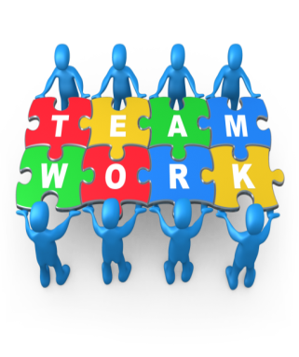

* Young people at risk of exploitation may be known to several agencies.
* One single agency may not have all of the answers or information they need and it is important that they communicate and work with each other and the young person to reduce risk.
* For young people who are about to, or have just turned 18, communication between Children’s Services and Adult Social Care is crucial in ensuring a smooth and co-ordinated transition.
* It is essential that safeguarding plans and other important measures are communicated to the young person’s GP.

**Further reading and resources**

[**Government guidance on County Lines**](https://www.gov.uk/government/publications/criminal-exploitation-of-children-and-vulnerable-adults-county-lines)

[**NWG Exploitation Response Network**](https://www.nwgnetwork.org/)

[**YMCA WiSE Project**](https://www.ymcadlg.org/what-we-do/support-and-advice/wise/) - **supporting children and young people to stay safe in their relationships.**

[**Sussex Police advice and information on Child Sexual Exploitation**](https://www.sussex.police.uk/advice/advice-and-information/caa/child-abuse/child-sexual-exploitation/)

[**Pace - Parents against child exploitation**](https://paceuk.info/)

[**Research in Practice: Transitional safeguarding - Bridging the gap**](https://www.rip.org.uk/news-and-views/blog/bridging-the-gap-transitional-safeguarding/)

**[Sussex Safeguarding Adults Procedures](https://www.sussexsafeguardingadults.org/)**

[**Sussex Child Protection & Safeguarding Procedures**](https://sussexchildprotection.procedures.org.uk/)

[**East Sussex Learning Portal**](https://eastsussexlearning.org.uk/)  **- training opportunities for staff working with children and young adults**

[**East Sussex SAB Information Sharing Protocol**](https://www.eastsussexsab.org.uk/information-resources/safeguarding-adults-board-information-sharing-protocol/)

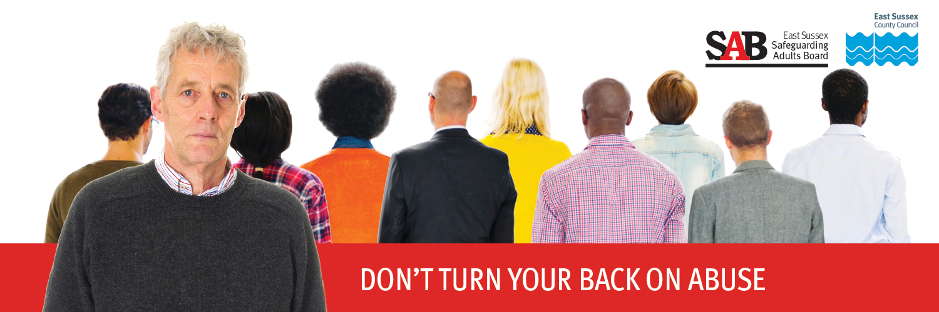

**Version 1 November 2019**