Learning Briefing
Safeguarding Adults Review Charlie

Sharing Learning
Preventing abuse and neglect is a key priority of the East Sussex Safeguarding Adults Board (ESSAB), the Brighton and Hove Safeguarding Adults Board (BHSAB) and East Sussex Safeguarding Children’s Partnership (ESSCP). We do this by sharing learning from Safeguarding Adults Reviews (SARs) and Local Child Safeguarding Practice Reviews (LCSPR) to drive improvement in safeguarding practice.

All staff and managers are encouraged to discuss and share the briefing, to ensure that the learning outcomes are used to consolidate existing best practice and develop practice where required.

Background

This review was commissioned to explore the circumstances that led to the death of ‘Charlie’ in April 2021, Charlie was 18 years of age and was transitioning from female to male.

Charlie had a substantial history with Children’s Social Care (CSC) and was known from shortly after his birth and was twice placed on a child protection plan. Charlie was also a looked after child under Section 20 of the Children Act 1989.

Charlie came out as transgender in 2019. Prior to this death he was referred to the Gender and Identity Development Service, following the referral the service was unable to make contact with Charlie. Charlie had some engagement with an LGBTQ+ Charity informing the charity workers that he wished to medically transition.

Sadly, Charlie struggled with mental health, alcohol misuse and significant self-harming episodes and declined hospital treatment.

Charlie had two periods in Hospital under Section 2 of the Mental Health Act due to his self-harm and risk he posed to himself. Following his second period in hospital, Charlie was discharged to temporary accommodation in Brighton where he continued to self-harm and drink significant amounts of alcohol. A short while after he moved into temporary accommodation, it is believed, that Charlie took his own life.

The review identified important learning for agencies, particularly in relation to the transition of young people to adult services, risk management and planning, self-harm, gender identify, trauma informed practice, mental health and Making Safeguarding Personal.

Areas of Learning:
1.Transitional Safeguarding

Unchallenged perceptions of child and adulthood and vulnerability and capacity can lead to young people falling through the ‘safeguarding net’. The safeguarding systems for children and adults are based on different legal and procedural frameworks and this has the potential to create gaps in operational practice. Basing safeguarding decisions on chronological age is fraught with challenges ignoring the developmental and behavioural challenges of becoming an adult.
The model of transitional safeguarding requires whole system change and a shared accountability by children’s safeguarding partners and strategic leads in adults’ services. As illustrated in the figure below ‘Bridging the Gap: Traditional safeguarding and the role of social work with adults’ suggest that Transitional policy and practice should be underpinned by three intersecting areas:

- Contextual or ecological safeguarding recognises and responds to harms young people face in a variety of spaces beyond their family and seeks to make these contexts safer rather than only focusing on the individual.
- Transitional or developmental safeguarding recognises the distinct developmental needs at this life stage and encourages greater fluidity between children and adult safeguarding services by an active effort to align systems to create a more holistic approach for those individuals.
- Relational safeguarding takes a person-centred, trauma informed approach; recognising that relationships are an important aspect of therapeutic support. In addition, this includes using language that is inclusive and is not victim blaming.
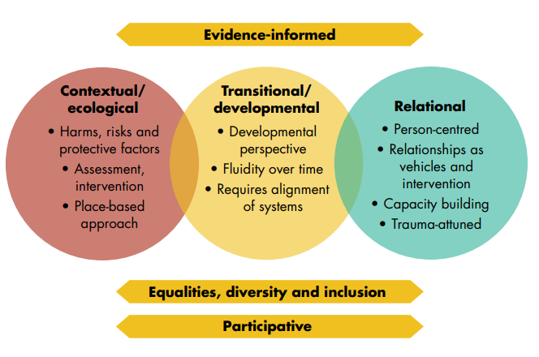
A transitional approach needs to be encompassed, enduring a participative user led approach; adopting a strengths-based approach, respecting young people’s expertise, and enabling them to coproduce solutions and support rather than being treated as a passive recipient.

2. Making Safeguarding Personal
Where there are concerns around engagement with services this should result in further enquiry or assessment. Agencies need to ensure a more person centred, flexible and relationship-based approach to support and services. The non-engagement of young people and adults should encourage professionals to work harder in meeting their specific needs rather than withdrawing support. Independent advocacy and assertive outreach, needs to be encouraged where agencies struggle to engage with professionals.

3.Mental Health
The Mental Health Act 1983 does not distinguish between different forms of mental disorder and therefore the Act applies to applies to personality disorders in the same way it applies to other mental disorders.
It is likely that the treatment options will be different, and this needs to be fully explained to the professional network working with young people and adults.
The review Identified a lack of professional understanding between agencies about what constitutes mental ill health and the respective responsibilities of agencies. This can lead to professional disagreement, challenge, and frustration. There needs to be a mechanism in place to avoid this and ensure there is multi-agency shared understanding, training, and risk assessment.
Unplanned discharge from hospital, places local authorities and other support services under significant pressure. The decision to discharge should be the subject of multi-agency agreement and decision making to agree effective planning and risk management.

4.Risk Management and Planning
Following the second period in hospital, Charlie was discharged with no care arrangements in place. He was consulted on the placement options and chose a self-contained flat as he did not want restrictive 1:1 staffing being offered at any alternative placement. The placing of young people in semi-supported accommodation at a young age with limited or no experience of living alone or semi-independently needs to be carefully risk assessed especially if there are no support mechanisms including visiting patterns in place.
The management of harm and risk of young people and adults needs to be shared across the multi-agency partnership and the appropriate use of the child safeguarding system to assess risks and needs for young people post 16 needs to be considered, particularly where self-harm is evident.
An Education Health and Care Plan (EHCP) can last until a young person is 25 years of age. Practitioners need to ensure EHCPs are factored into young adult care planning where they exist.
5.Self-Harm

Charlie had suicidal thoughts and significantly self-harmed on many occasions and refused hospital treatment.
- Nice Guidance on self-harm, published in September 2022, recommends assessments of capacity under the Mental Capacity Act 2005 should be considered when young people or adults who are significantly self-harming are unable to make effective decisions for themselves whilst under the influence of drugs or alcohol.

- Young people’s use of alcohol should be risk assessed, particularly if this is a trigger for self-harming behaviours. Alcohol use is as significant as self-harming behaviours and needs to be given equal weight in terms of the risk to health.
- East Sussex alcohol harm reduction strategy 2021-2026 priorities 2 and 3 notes that Children’s services in East Sussex ensure effective interventions for young people where alcohol has been identified as an issue. Specialist assessment and treatment intervention is provided for young people up to the age of 21 years and to care leavers and vulnerable people up to 25 years via the multi-agency and multi-disciplinary Under 25s Substance Misuse Service.

6.Social Media and Suicide
Suicidal ideation in adolescents with mental health problems and their sharing on social media platforms can be an indicator for suicide.
To identify risks, professionals should take a person-centred approach; talking to individuals about their needs and wants, abilities, experiences and influences and particular vulnerabilities, such as suicide that may be amplified online.
There are various steps you can take to prevent and respond to risk including:
- Supporting the person to keep themselves safe online such as discussing the types of online activities which would be illegal or inappropriate and where they would go for help and support if they need it.
- Checking your organisation has sufficient risk management policies and processes in place.
- The importance of Safety Plans - an agreed set of activities, strategies, people, and organisations to contact for support if someone becomes suicidal or if their suicidal thoughts get worse or if they might self‑harm. The Royal College of Psychiatrists believe that every person who is having suicidal thoughts or who has engaged in self‑harm should have a Safety Plan.
Key learning points for reflection and team discussions

Reflecting on the key principles of Transitional Safeguarding think about your practice and identify at least one demonstrable strength in relation to:
- What would you consider when offering a trauma-informed response to young adults experiencing harm?

- Assessments – how would you balance the consideration of both the individual needs and developmental stage of the young adult as well as the structural and contextual factors that influence their lives?

Further reading and resources
SAR Charlie Executive Summary
Self-Harm and Suicide in Adults
Mental Capacity Act Multi-Agency Policy and Procedures
Sussex Safeguarding Adults Policy and Procedures
Multi-Agency Risk Management Protocol
The Importance of Multi-Agency Meetings Learning Briefing
Reporting a Safeguarding Concern
Preventing suicide among trans young people: A toolkit for nurses
Independent review of gender identity services for children and young people
Self-harm Toolkit

A range of multi-agency safeguarding courses, including Trauma Informed practice, Suicide Awareness, Safeguarding Issues in an LGBTQ Context, and Mental Capacity Act training are available through the East Sussex Learning Portal.

If you require further information about the review, please contact:
Lucy Spencer, SAB Development Manager lucy.spencer@eastsussex.gov.uk

