East Sussex

Partnership Protocol

2022-24

East Sussex Partnership Protocol 2023 - 24

Joint working across the partnerships

1.1 This protocol is intended to support effective joint working between the following strategic partnership boards (‘the partnerships’) in East Sussex:
- East Sussex Safeguarding Adults Board
- East Sussex Safeguarding Children Partnership
- East Sussex Safer Communities Partnership Board
- East Sussex Children and Young People’s Trust.
1.2 These partnerships are committed to ensuring that safeguarding is everyone’s responsibility and to working together at every level to keep people in East Sussex safe from harm and abuse and improve their health and wellbeing. The partnership arrangements with the East Sussex Health and Wellbeing Board are less directly aligned than with the other partnerships within this protocol as detailed at point four.
1.3 The partnerships referred to in this document also maintain close links with other safeguarding boards which operate on a Sussex-wide basis, reflecting commitment to a shared vision and collaboration regarding common themes and priorities.
1.4 Collaboration between the partnerships is based on following principles:

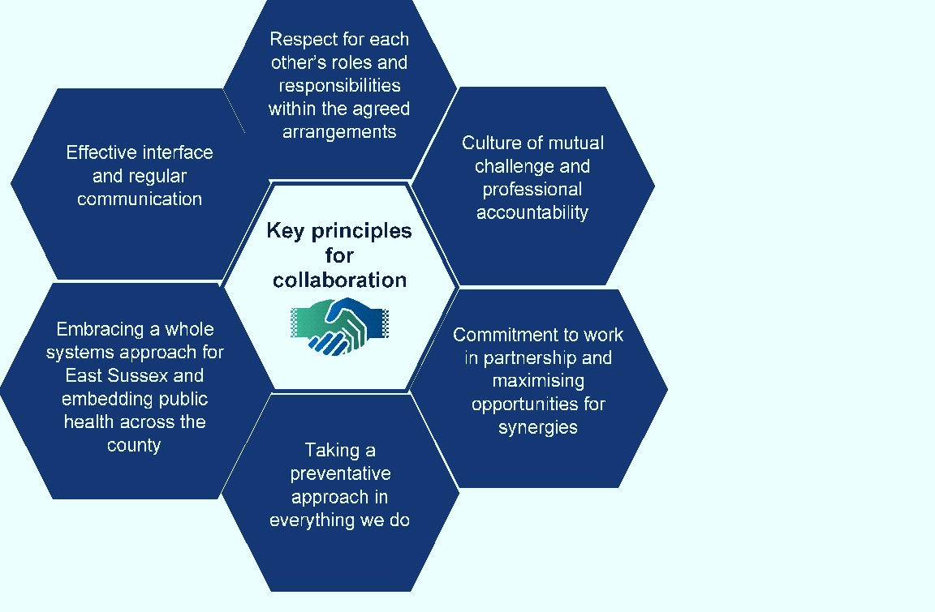

Image courtesy of West Sussex Four Board Collaborative Agreement

Purpose of the Partnership Protocol

2.1 The East Sussex Partnership Protocol governs relationships between key agencies working to promote the health and wellbeing of East Sussex’s communities. In relation to safeguarding, the protocol aims to secure coordinated partnership working that avoids duplication and achieves better outcomes for the people of East Sussex.
2.2 This document sets out the expectations of the relationships and working arrangements between the above listed partnerships, and covers respective roles and functions, shared priorities and arrangements for oversight, challenge, and scrutiny.
2.3 Each Board has specific statutory duties, powers, and roles. This protocol is intended to support the effectiveness of each partnership board. It is not intended to override or replace the statutory duties or powers of any of the individual agencies. Further details can be found on the respective website for each board/partnership/trust.

Objectives of the Partnership Protocol

3.1 Each of the partnerships share a common ambition to improve the welfare and safety of people in East Sussex. Within the wider governance arrangements of the partnerships, their role is to ensure the effectiveness of the arrangements made by individual agencies and partners to safeguard and promote the welfare of adults, young people, and children.
3.2 The opportunities presented by a formal working relationship between the partnerships and boards include:
- Achieving a coordinated approach to delivering the boards and partnerships’ goals, recognising that agency members and partnerships operate within the same geographical boundary and therefore serve the same population within East Sussex.

- Adopting a coordinated approach to ensure the safety and health and wellbeing of adults and children in East Sussex are collectively addressed with a focus on early intervention and prevention.

- Share relevant information across partnerships and member organisations and align business plans with shared strategic priorities to tackle key issues - such as serious violence, domestic abuse, and exploitation - which impact on the health, safety, and wellbeing of the residents of East Sussex.

- Understanding the importance of consultation, engagement, and feedback within our local communities to inform the partnership boards’ business and priorities.

- Strategic plans, whether formulated by individual agencies or by partnerships, include safeguarding as a theme, to ensure that existing strategies and service delivery, as well as emerging plans for improvement, include effective safeguarding arrangements.

- Identifying areas of commonality and pooling evidence, expertise, and resources to influence policy, practice, and outcomes locally.

- Ensuring health, wellbeing and safeguarding is everyone’s responsibility and each organisation and individuals within those organisations must play their full part.

- Sharing learning from safeguarding reviews and building on strengths and using our collective resources to address areas of concern or which require further development.

Partnership arrangements with the Health and Wellbeing Board (HWB)

HWBs were established by the Health and Social Care Act 2012. They are a forum for leaders from the health and social care system with responsibilities for commissioning and providing health services, public health, and social care to work together to improve the health and wellbeing of the local population and reduce health inequalities.

HWB members collaborate to understand the needs of the local community, agree priorities through the Joint Strategic Needs Assessment (JSNA) and Health and Wellbeing Strategy. The HWB has strategic influence over commissioning decisions across health, public health and social care through the Health and Wellbeing Strategy and the NHS Sussex Integrated Care Strategy and Shared Delivery Plan (SDP). The HWB has an interest in the wider determinants of health and wellbeing including housing and education.

There is a statutory requirement for the East Sussex Safeguarding Adults Board and East Sussex Safeguarding Children Partnership to present their annual reports to the HWB.

Mechanisms for collaboration

To achieve our aims the partnerships will:
- Present their annual reports and/or business priorities to each other’s boards as well as to the HWB upon request. Sharing annual reports provides an opportunity for the boards and partnerships to comment on performance, progress of areas of joint working, and identify any future areas for joint working.

- Share formal board meeting discussions. Meeting agendas and resulting actions/recommendations for the four boards and partnerships will be shared with the respective chairs and business managers. This will provide an opportunity for support, challenge, and alignment of business plans to feed into the planning process for strategies and plans.

- Members who sit on more than one board are expected to attend meetings regularly. They have a key role in ensuring they represent their organisations and share information on the issues and concerns being discussed at both boards. They are a key mechanism for linking and sharing information at this strategic level.

- Identify the lead partnership and respective responsibilities for a particular issue or priority and adopt a collaborative approach across policies or areas of mutual interest.

- Ensure that there is a shared approach to practice reviews in the county and the learning to emerge from these, this will include:

- Local Child Safeguarding Practice Reviews (LCSPRs)
- Safeguarding Adults Reviews (SARs)
- Domestic Homicide Reviews (DHRs)
- Offensive weapons Homicide Reviews (OWHRs)
- Drug and Alcohol Related Deaths (DARDs)

- Identify opportunities to develop joint communication plans, to ensure that key safeguarding messages are shared effectively across the partnerships and partner organisations.

- The partnerships will ensure a lead is identified to review all respective strategic priorities.

Shared priorities and responsibilities

There are a number of shared priorities where the partnership Boards will need to ensure that leadership and accountability for issues is clear, and that information is effectively shared. These shared priorities relate to protecting adults and children from harm, abuse and neglect and include:

- Domestic and sexual violence and abuse.
- Mental health and emotional wellbeing.
- Child and adult exploitation, missing people, rape and sexual violence and abuse, and harmful practices (Female Genital Mutilation, Forced Marriage and ‘so called’ Honour Based Violence).
- Serious and organised crime, including modern slavery, human trafficking, county lines and fraud and scams.

Newly emerging themes which the partnerships will prioritise over this year will include:
- Serious violence, including firearms, knife crime and homicides.
- Drug and alcohol related harm/death.
- Transitions from Children’s to Adult’s Services.
- Working with multiple compound needs and adopting a trauma-informed approach.
6.3 Where a piece of work with cross-cutting themes is identified, the other boards will be contacted to clarify the relevance of the theme for them. The relevant boards will then agree:
- Responsibility and accountability for the area of work.
- Which board will lead and the mechanisms for other partnerships to support and feed into this work.
- Information sharing and reporting arrangements.

Review of protocol

7.1 The Business/Development Managers across the Safeguarding Adults Board, East Sussex Safeguarding Children Partnership and Safer Communities Partnership meet on a bi-monthly basis to progress areas of work in relation to shared priorities, including sharing updates on practice reviews, establishing work within the parameters of the protocol, and producing joint communications and briefings.
7.2 The effectiveness of this protocol will be reviewed and evaluated at least annually by the Business/Development Managers across the partnerships, where joint areas of work for the forthcoming year will be agreed.

Partnership working in practice: Sharing learning

One of the aims of this protocol is to develop arrangements with other Boards to respond to and capture emerging safeguarding themes.
In 2022, a meeting between partnership boards took place to compare current action plans/emerging themes and current learning. This was presented to the Safer Communities Board: Learning from Partnership Reviews and was also presented as part of the NHS Sussex Safeguarding fortnight.

Common learning themes identified were:
- The need for a multi-agency trauma informed response
- The importance of communication directly with the child/adults ( and advocate where applicable)
- The importance of building effective relationships with the family ( including the assessment of risk to family members)
- The transition from child to adult services
- The impact COVID 19 had on services and families/individuals
- The tactics employed by families/perpetrators to attempt to obstruct and deflect agencies from safeguarding the child/adult
- The value of meaningful engagement
- Information sharing between agencies

Agree outcomes from the identification of these common areas:
- Bi-monthly meetings take place between review managers which include sharing recommendations to avoid duplication and support a more systematic approach
- Standing item on reviews, action planning and progress at the East Sussex Domestic Abuse and Sexual Violence Management Oversight Group
- Joint learning briefings to themes across reviews
- Safeguarding conferences and events linked to learning from reviews
- DHR and SAR thematic actions plans developed
- Annual presentation to the Safer Communities Board on key learning from reviews

Partnership Working in Practice: Domestic Abuse

The Domestic Violence and Sexual Abuse Management Oversight Group provides strategic and operational oversight of multi-agency responses in East Sussex to domestic violence and abuse (DVA), sexual violence (SV) and other forms of violence against woman and girls (VAWG). This group is accountable to the East Sussex Safer Communities Partnership and includes representation from the Safeguarding Children Partnership and Safeguarding Adults Board.
The overarching strategic outcome for the group is that local residents and communities are free from DVA, SV and VAWG by increasing survivor safety; holding perpetrators to account; decreasing social tolerance and acceptance; and increasing people’s ability to have violence-free, safe, and equal lives.
Areas of responsibility for the group include:
- Supporting planning for future service delivery by maintaining a picture of victim and perpetrator profiles in East Sussex.
- Identifying any emerging risks and issues and agree appropriate actions.
- Monitoring the performance, quality, and effectiveness of the Multi-Agency Risk Assessment Conference (MARAC) process and develop, coordinate, and monitor a MARAC action plan.

The group also supports the sharing of learning from DHRs, and relevant recommendations from CSPRs and SARs any other relevant review commissioned by a local organisation or partnership.

The partnership boards continue to jointly deliver multi-agency training in relation to domestic violence and abuse to support a whole family approach in understanding the impact of domestic abuse of children on adults.

Appendix 1

About the Boards and Partnerships
The following section gives an overview of each board or partnership, its purpose and statutory responsibilities, interdependencies with the other boards or partnerships, and where to find further information.

East Sussex Safeguarding Adults Board
Board Purpose
The East Sussex Safeguarding Adults Board is a multi-agency statutory partnership, established by the Care Act 2014, which provides leadership and strategic oversight of adult safeguarding work across East Sussex.
The overarching purpose of the Safeguarding Adults Board is to help and safeguard adults with care and support needs from abuse, neglect, and exploitation.
The shared vision of the East Sussex Safeguarding Adults Board is for all agencies to work together effectively to enable the citizens of East Sussex to live free from abuse and neglect, and to promote widely the message that safeguarding is everybody’s business. Members of the Safeguarding Adults Board work together to:
- Actively promote collaboration and commitment between organisations.
- Work together on prevention strategies.
- Listen to the voice of adults with care and support needs and carers to deliver positive outcomes.

Statutory duties
Under the Care Act 2014, we are required to:
- Develop and publish and Strategic plan setting out how we will meet our objectives and how our partner agencies will contribute to this.
- Publish an Annual Report detailing how effective our work has been.
- Arrange for SARs to be undertaken when the criteria are considered to have been met.
Board Priorities
The current East Sussex Safeguarding Adults Board objectives and priorities are set out in the Strategic Plan 2021 - 2024
Key priority areas are:
- Embedding MCA in practice.
- Safeguarding transitions for young people at risk.
- Working with multiple complex needs.
- Additional areas of self-neglect, homelessness and safeguarding the increasing migrant population will be featured in and alongside these priorities.
East Sussex Safeguarding Children Partnership
Partnership Purpose
The purpose of the East Sussex Safeguarding Children Partnership is to support and enable all professionals working with children and families in East Sussex to work together in a system where:
- Children are safeguarded and their welfare promoted.
- Partner organisations and agencies collaborate, share, and co-own a vision for safeguarding children.
- There is early identification and analysis of new safeguarding issues.
- Learning is promoted and embedded in a way that local services for children and families can become more reflective and implement changes to practice.

Information is shared effectively to facilitate accurate and timely decision making for children and families.
Statutory Duties
The Children Acts of 1989 and 2004 set out specific duties: section 17 of the Children Act 1989 puts a duty on the local authority to provide services to children in need in their area, regardless of where they are found; section 47 of the same Act requires local authorities to undertake enquiries if they believe a child has suffered or is likely to suffer significant harm.
These duties placed on the local authority can only be discharged with the full cooperation of other partners, many of whom have individual duties when carrying out their functions under section 11 of the Children Act 2004. Under section 10 of the same Act, the local authority is under a duty to make arrangements to promote cooperation between itself and organisations and agencies to improve the wellbeing of local children.
The Children Act 2004, as amended by the Children and Social Work Act 2017, strengthens this already important relationship by placing new duties on key agencies in a local area. Specifically, the police, integrated care boards and the local authority are under a duty to make arrangements to work together, and with other partners locally, to safeguard and promote the welfare of all children in their area.

Safeguarding partners are required to publish their arrangements, and to ensure scrutiny of how effective the arrangements have been by an independent person and to prepare and publish, at least once in every 12-month period, a report on the work that they have done as a result of their arrangements, and how effective the arrangements have been in practice.

Partnership Priorities
East Sussex Safeguarding Children Partnership Priorities for 2023 onwards are:
- Safeguarding children in schools including safeguarding children who are electively home educated, excluded from school, and missing education.

- Safeguarding adolescents including adolescents who are criminally exploited, self-harm and/or express suicidal thoughts, child to parent abuse, and transitional safeguarding.

- Embedding learning and evidencing impact from case review and audit work, including ensuring that learning from the 2020-23 priority on safeguarding infants was embedded.
It is considered that the voice of the child and contextual safeguarding should be cross cutting over all the East Sussex Safeguarding Children Partnership priorities.
East Sussex Safeguarding Children Partnership Annual Report and Business Plan

East Sussex Safer Communities Partnership
Partnership Purpose
The East Sussex Safer Communities Partnership is committed to reducing and preventing crime, the fear of crime, anti-social behaviour, re-offending, domestic abuse, combating the misuse of drugs, alcohol and other substances and ensuring services are delivered effectively on a local level.
The East Sussex Safer Communities Partnership is the statutory County Strategy Group which provides strategic leadership for addressing community safety matters across East Sussex.
The partnership is accountable to the East Sussex County Council Scrutiny Committee and through the Lead Member for Adult Social Care. Agencies with a responsibility for community safety as required by The Crime and Disorder Act 1998 to share information and work together to address crime and disorder. This includes publishing a plan for the reduction of crime and disorder in their area.
The East Sussex Safer Communities Partnership priorities are cross cutting and continue to be closely aligned with other plans that involve working with local communities and partners to keep East Sussex safe.

Statutory Duties
The Crime and Disorder Act 1998 gave specified authorities a duty to work together to develop crime and disorder audits and implement reduction strategies.
- Section 5 of the Act sets out that the specified authorities’ joint responsibility for preventing and reducing crime and disorder in the area. They are ‘responsible authorities’ and have a duty to co-operate through a Community Safety Partnership. These partnerships have a statutory duty to reduce reoffending; tackle crime and disorder; anti-social behaviour; alcohol and substance misuse; and any other behaviour which has a negative effect on the local environment.
- The ‘responsible authorities’ have responsibility, under Section 6 of the Act, for formulating and implementing ‘a strategy for the reduction of crime and disorder in the area’. ‘Before formulating the Strategy, the responsible authorities shall carry out, taking due account of the knowledge and experience of persons in the area, a review of the levels and patterns of crime and disorder in the area and of the level and patterns of the misuse of drugs in the area.’ This is known as the Strategic Assessment.
- Section 17 of the Act place a duty on the local authority to “Without prejudice to any other obligation imposed upon it, it shall be the duty of each authority … to exercise its various functions with due regard to the likely effect of the exercise of those functions on, and the need to do all that it reasonably can to prevent, crime and disorder in its area (including anti-social and other behaviour adversely affecting the local environment) and the misuse of drugs, alcohol and other
substances in its area”.
Domestic Homicide Reviews (DHRs)
DHRs were established on a statutory basis under the Domestic Violence, Crime and Victims Act 2004. DHRs are commissioned by the East Sussex Safer Communities Board and paid for by contributions by core statutory partners: ESCC, NHS East Sussex Clinical Commissioning Group, National Probation Service, and the District and Borough Community Safety Partnerships, with ad hoc discretionary contributions from other community safety partners, such as East Sussex Fire and Rescue Service. The Multi-agency Statutory Guidance for the Conduct of DHRs was last refreshed in 2016. In line with the national Ending Violence Against Women and Girls (VAWG) strategy, currently being refreshed, the statutory guidance reinforces the position that domestic violence and abuse is ‘everyone’s business’.
DHRs have a key role in this as their main purpose is to prevent domestic violence and homicide and improve service responses for victims by developing a coordinated multi-agency approach to ensure that abuse is identified and responded to effectively at the earliest opportunity. The guidance highlights the importance of taking a holistic approach when considering the facts presented during scrutiny of practice by agencies and professionals.
The Counter Terrorism and Security Act 2015, Section 26 places a duty on specified authorities, in the exercise of their functions, to have “due regard to the need to prevent people from being drawn into terrorism”.
The Modern Slavery Act 2015 consolidated the current offences relating to trafficking and slavery and introduced a range of new measures around the prevention of modern slavery events and the support and protection of victims of modern slavery. Under the Act, specified authorities have a duty to notify the Home Office of any individual encountered in England and Wales who they believe is a suspected victim of slavery or human trafficking.
There is a pending serious violence duty on public bodies which will ensure relevant services work together to share data and knowledge in order to target interventions and reduce serious violence.
Board Strategic Priorities 2023 – 2026:
- In protecting vulnerable people, workstreams range from improving online safety to disrupting modern slavery and protecting people from domestic and sexual violence and abuse.
- In identifying those at risk of harm, workstreams range from preventing people from being drawn into violent extremism to reducing the harms associated with drug and alcohol misuse.
- In keeping communities safe, workstreams range from improving road safety to reducing public place anti-social behaviour (ASB) and serious violence.
East Sussex Children and Young People’s Trust
Trust’s Purpose
The aim of the Children and Young People’s Trust is to work collaboratively to improve the outcomes for children, young people, and families.

Statutory Duties
The Children and Young People’s Plan constitutes the statutory Child Poverty Strategy for East Sussex.

Trust’s Priorities
- Improve the school readiness of pupils.
- Helping more parents enter, sustain and progress in work.
- Improve the quality of life of low income families in other ways where possible.
- Ensuring effective early help and safeguarding for children and young people.
- Improving education, attainment and skill levels of young people aged 14 -19, including through a strong academic route and better access to a wider range of apprenticeships, vocational training and work experience opportunities.
- Improving support to children, young people and families to help maintan and enhance emotional wellbeing and mental health.

