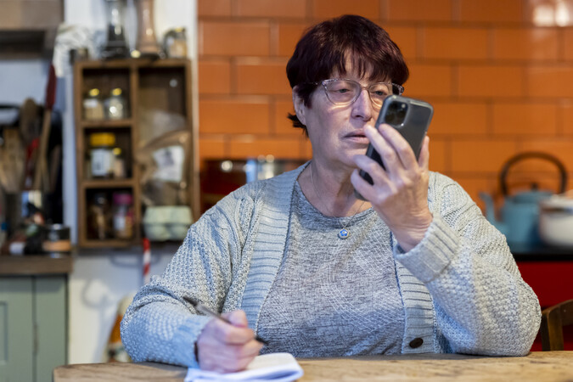
Digital Safeguarding

This leaflet highlights some of the risks for vulnerable adults who use social media and the internet.
Digital safeguarding - simply means taking steps to stay safe online.
The internet can give adults a wide range of options and tools to manage their lives and keep in contact with people. However, it can also expose them to abuse and crime. The number of issues that could be regarded as harmful online is considerable: being exposed to illegal, inappropriate, or harmful content, for example pornography, fake news, racism, self-harm, suicide, radicalisation, and extremism. Descriptions of some of the issues are highlighted below:
- Digital coercive control - technology increasingly features in intimate relationships and is used by domestic violence perpetrators to enact harm.

- Harmful content disguised as support - online platforms can provide vulnerable adults with opportunities to view upsetting and graphic content that could cause them harm, including pro-suicide and self-harm.

- Digital self-harm is when an individual targets themselves with negative content online. The purpose may be to cause psychological distress to themselves or to communicate psychological distress indirectly. Digital self-harm can include any way of intentionally seeking out hurtful content-- such as creating negative content about themselves or posting abusive comments on their own content.

- Online abuse can take many different forms and can affect anyone. Examples include:

- Trolling: When someone deliberately posts offensive, upsetting, or inflammatory comments online in an attempt to hurt and provoke a response.
- Revenge porn: Is the sharing of private, sexual materials, either photos or videos, of another person without their consent and with the purpose of causing embarrassment or distress.
- Cyber-stalking: Is a pattern of online behaviour that is the long-term, intrusive, and persistent pursuit of one person by another, making the victim feel frightened and distressed.
- Grooming: Is when someone builds an emotional connection with a child, young person, or adult to gain their trust for the purposes of sexual abuse, sexual exploitation, or trafficking.
- Romance fraud: Is the engineering of a supposed friendship or relationship for fraudulent, financial gain. Romance fraud is one of the fastest growing crime types affecting the vulnerable, so much so that in Sussex all victims of romance fraud are treated as vulnerable by crime type. The financial losses are high, and victims can often be in denial, making self-reporting low and repeat victimisation likely.
Identifying risk
Consider the person’s wants and needs, abilities, experiences, and influences. They may have particular vulnerabilities that are amplified online. Talk to them about what they enjoy most about the internet, ask them how, where and when they go online, as well as what they do and who they are talking to.
Data implies that a high proportion of romance fraud victims are lonely, widowed or recently bereaved, have suffered from a recent break up and/or suffering from depression.
Responding to risk
There are various steps you can take to help prevent and respond to risks:
- Support the person to keep themselves safe online. Technical settings (blocking, filtering, passwords etc.) may be appropriate. Discuss the kinds of online activities which would be illegal, inappropriate, or break an app’s terms & conditions. Where would they go for help if they needed it?

- In relation to social media harassment/abuse record every interaction and conversation. By capturing detailed records related to online abuse, identifying those responsible and holding them accountable becomes much easier.

- Ignoring and refusing to respond can be the difference between escalating an already dangerous situation or staying safe. In cases where a situation rapidly escalates, blocking (calls/online activity) that person can be a good idea. However, this must be considered in the context of the situation such as stalking cases where it is advisable to mute and not block them.

- Veritas Justice who provide advocacy casework to all victims of stalking across Sussex advise not blocking messages or online communication between an individual and the stalker as this may increase the risk of them trying to seek the victim out in person and may also elevate their level of anger.

- Communication can be used as evidence of a pattern of behaviour. They advised sending one message to the person asking them not to make contact.

- If you suspect a crime has taken place or is taking place report it.

- Share and promote the Little Book of Big Scams to raise awareness and educate which describes the current types of fraud people are experiencing today.

Online Safety Act 2023
The Online Safety Act makes businesses, and anyone else who operates a wide range of online services, legally responsible for keeping people in the UK safe online.
How the Online Safety Act will protect adults:
The Bill will protect adults in three ways through a ‘triple shield’. Platforms will need to:
- Remove all illegal content.
- Remove content that is banned by their own terms and conditions.
- Empower adult internet users with tools so that they can tailor the type of content they see and can avoid potentially harmful content if they do not want to see it on their feeds. Children will be automatically prevented from seeing this content without having to change any setting.
Illegal content
Some content that children and adults encounter online is already illegal. The Bill will force social media platforms to remove all illegal content, stopping children and adults from seeing it.
The Bill is also bringing in new offences, including making content that promotes self-harm illegal for the first time. Platforms will need to remove this.
This is not just about removing existing illegal content; it is also about stopping it from appearing at all. Platforms will need to think about how they design their sites to reduce the likelihood of them being used for criminal activity in the first place. Some of the illegal content that platforms will need to remove includes:
- controlling or coercive behaviour
- extreme sexual violence
- fraud
- promoting or facilitating suicide
- promoting self-harm

Reporting concerns
- If you are worried that someone is being abused, neglected, or exploited
Report a concern about an adult | East Sussex County Council

- Stalking and harassment
National Stalking Helpline | Suzy Lamplugh Trust

- Hate crime and Harassment
Safe: Space Sussex - Harassment and online bullying (safespacesussex.org.uk)

- Fraud
Operation Signature | Sussex Police

- Report a suspicious website
Report a suspicious website - NCSC.GOV.UK

- Revenge Porn
Revenge porn | Sussex Police

- Romance Fraud – anonymous reporting
You can report suspicions of romance fraud anonymously to Scamalytics using an online form where you can enter images, names, and details of potential romance fraudsters. This not only keeps the adult safe but could prevent others from falling victim too.

Further resources
- Online harms | Local Government Association

- Help and advice Get East Sussex Safe Online (safeineastsussex.org.uk)

- Help and advice about Fraud and Rogue Trading in East Sussex (safeineastsussex.org.uk)

- How to Stay Safe Online – Guidance for Adults and Young People with Learning Disabilities – Digital Safeguarding

- Supporting Vulnerable Groups Online - UK Safer Internet Centre

- East Sussex Personal - Get Safe Online

- The animated film, entitled ‘Safety Net’, has been developed as an accessible guide to keep everyone safe online and is specifically aimed at adults with a learning disability and autistic people. Safety Net can be viewed here Safety Net - An accessible guide to keeping everyone safe online - YouTube

