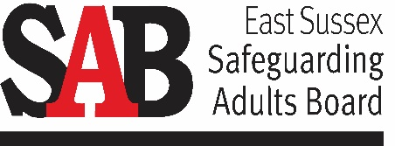 | Learning From  Safeguarding Audits  Complex Cases  This briefing summarises the findings and learning outcomes of a SAB multi-agency audit of complex safeguarding cases in November 2018.  Staff in all SAB partner agencies working with adults with care and support needs are encouraged to read the briefing and discuss it in their team meetings.
…
Background to the audit:
The Performance, Quality and Audit (PQA) Subgroup undertakes themed multi-agency audits on behalf of the East Sussex Safeguarding Adults Board (SAB). In November 2018 the PQA Subgroup conducted an audit of complex safeguarding cases.
The audit group comprised representatives from East Sussex Adult Social Care & Health, Sussex Police, East Sussex CCGs, Sussex Partnership NHS Foundation Trust (SPFT), East Sussex Healthcare NHS Trust (ESHT), National Probation Service, Eastbourne Borough Council, Change Grow Live (CGL), BHT/Fulfilling Lives and Kent Surrey and Sussex Community Rehabilitation Company (KSS CRC).
The focus of the audit was to assess how partner agencies work together to manage complex safeguarding cases with particular reference to the effectiveness of approaches to:

- Adults with complex and multiple support needs including high risk factors such as substance misuse and mental health issues.
- Adults who self-neglect.
- Adults who may lack capacity.
- Adults who practitioners may find challenging to engage.

In each case the audit considered agencies’ responses to each case and assessed effectiveness in the following areas:

- Risk assessment
- Safeguarding planning & intervention
- Multi-agency working including information Sharing.
- Multi-agency working
- Professional knowledge and professional curiosity
- Management oversight & supervision.
- Making safeguarding personal

The audit looked at five cases, all involving complex issues and multi-agency involvement.
Case A | A woman with schizophrenia and complex support needs including alcohol misuse and self-neglect.
Case B | A male carer at risk from abuse from a close relative with serious mental health issues.
Case C | A complex case involving a woman with physical health support needs and at risk due to self-neglect, substance misuse and domestic abuse.
Case D | A man with complex and multiple support needs including physical disability and issues around substance misuse, self-neglect and exploitation.
Case E | A woman with a learning disability at risk of sexual and financial exploitation.
For further information in relation to this briefing or if you would like a copy of the full audit report, contact George Coleby, Quality Assurance & Learning Development Officer george.coleby@eastsussex.gov.uk or 07712 236676
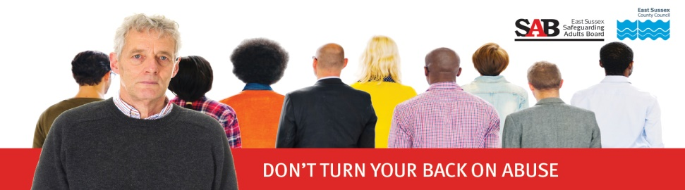

The audit findings and recommendations
The audit identified a number of strengths and examples of good practice and some areas for improvement and development. The main findings and recommendations are summarised below.
What was done well | What could be improved and areas for development
- Effective multi-agency working and information sharing in several cases including good use of multi-disciplinary team meetings. | - Communication between agencies could have been better in some cases, for example in relation to sharing of meeting minutes and communication with Primary Care agencies.
- The application of ‘Making Safeguarding Personal’ in several cases. | - The audit raised the importance of communication and involvement of family members in complex cases.
- Good use of the self-neglect procedures in one particular case. | - Agencies would find it helpful to have a specific risk assessment template for use with the self-neglect policy and procedures.
- Professional curiosity demonstrated and exploration of alternative options including legal avenues, to reduce risk. | - The audit highlighted that third sector organisations may not be aware of avenues to challenge decisions within safeguarding processes, for example the SAB Resolution Protocol.
- Some cases demonstrated good knowledge and application of the Sussex Safeguarding Adults Policy and Procedures by the agencies involved. | - The audit identified some issues with how safeguarding concerns and enquiries are identified and recorded.
- Consideration and application of the Human Rights & Mental Capacity Act principles. | - Feedback to referring agencies on safeguarding concerns and subsequent actions could be more consistent.
- Persistence, patience and flexible approach by practitioners when working with adults who at times appear to be difficult to engage. | - Some cases in the audit highlighted the potential benefits of more joint working between specific agencies to meet the challenges of engaging with adults who may at times be difficult to engage.

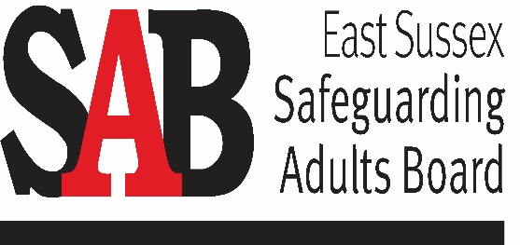
The audit group has developed an action plan to address the areas for improvement and development.

Progress in implementing the action plan will be monitored by the PQA Subgroup.

The importance of communication Resolving problems

All professionals should feel able to challenge decision making and to see this as their right and responsibility in order to promote the best multi-agency safeguarding adults and mental capacity practice.
The SAB Resolution Protocol sets out a process for managing disagreements between agencies or professionals in relation to safeguarding or mental capacity decision making, highlighting the importance of effective partnership working and professional co-operation in resolving disagreements in the shortest timescales possible.
The audit highlighted the importance of effective communication between agencies working together in complex safeguarding cases.
How can communication be improved?
- Think about who needs to be involved in multi-agency meetings and plans. It is especially important to consider how GP practices can contribute to the process and what information they need or can provide.
- When circulating notes of meetings and agreed actions, make sure you include agencies who were not present at the meeting but who need to know what was agreed.
- Think about family members and friends; talk to the adult concerned – who do they want to be involved?
- Provide feedback to those who raise safeguarding concerns. Keep them informed throughout the process and let them know the outcome.

‘Honest disagreement is often a good sign of progress’
Mahatma Gandhi

The SAB Information Sharing Protocol sets out an agreed set of principles and standards about sharing confidential and sensitive personal data.

Making safeguarding personal Working with adults who may be difficult to engage
In line with Making Safeguarding Personal it is important to promote a person’s choice and control whilst recognising the statutory obligations to protect people from the risk of abuse or neglect and harm. Effective engagement can be achieved by applying key principles of respect, equality, partnership, social inclusion and empowerment. Practitioners should show compassion and understanding of the complexity of the person’s background and how this has led to their current circumstances.
Key principles:
- Who is best placed to work with and build a trusting relationship with the adult? Who else can support with this, e.g. a family member, advocate, other professional?
- Find the right tone. It is important to be honest about potential consequences while being non-judgemental and separating the person from the behaviour.
- Progress at the adult’s pace. Allow conversations to take place over a period of time, and to focus on finding what motivates the person.
- Ensure that the adult receives information about practical options for support in a format they can understand. Check whether the person understands these options and the consequence of their choices.
- If there is doubt about a person’s mental capacity, carry out a decision specific capacity assessment.
- Develop a plan which clearly sets out options and agreed actions. It is important to offer choices and have respect for the person’s judgement.
- Ensure the person is involved as much as possible, for example making sure the person is invited to attend meetings.
- It is also important that front-line practitioners have access to effective supervision and training within their organisation.

The audit reinforced the importance of Making Safeguarding Personal and ensuring that feedback from adults who are the subject of safeguarding enquiries is used and learnt from.

One of the cases audited involved a female adult with multiple & complex support needs including a history of abusive relationships, self-neglect, substance misuse, self-harm, and offending behaviour.

One of the main challenges in this case was the adult’s chaotic lifestyle and her suspicion of agencies.

However, staff in the agency supporting her have, through flexibility and persistence, managed to maintain contact and met with her to ask her about her experience of the safeguarding process. She provided valuable feedback which is now being considered to see how services provided to adults with complex needs, including substance misuse, can be better supported on their release from prison
Professional curiosity

One of the cases audited involved a woman with a learning disability who was at risk of sexual and financial exploitation. Although there was generally a good multi-agency response to reduce risk in this case the audit group felt there was one occasion when a health professional should have demonstrated greater professional curiosity.
The Sussex Safeguarding Adults Policy and Procedures provide useful guidance on how to talk to an adult who may be at risk from abuse.
- Always speak to the adult in a private place where they are likely to feel safe.
- Use open questions to gain an understanding of the situation, the adult’s wishes and what actions may need to be taken. Do not ask leading questions or begin to make enquiries inappropriately.
- If something has happened, get the adult’s views on what has happened and what they want done about it.
- Give the adult information about advice, support and different options that may be available to them in an accessible format, and about the safeguarding adults procedures and how these could help to make them safer, and about responsibilities of people working with adults to share information where there may be concerns of abuse or neglect.
- Support the adult to ask questions about issues of confidentiality.
- Consider any advocacy support needs.
- Explain what will happen next, and how they will be kept informed and supported

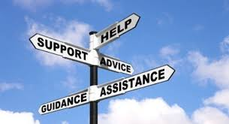
East Sussex has developed guidance on raising concerns about abuse and neglect to help to develop greater confidence and consistency in deciding when an issue is a safeguarding concern or not.
The guidance is designed to assist practitioners and providers across all agencies in considering risk relating to potential safeguarding concerns involving adults with care and support needs. It aims to enable safeguarding concerns to be reported when it is appropriate to do so and ensure that they are responded to in a consistent way.
The guidance should be used in conjunction with the Sussex Safeguarding Adults Policy and Procedures and each agency’s own safeguarding policy and procedures.

Additional information and further reading
Sussex Safeguarding Adults Policy and Procedures

East Sussex Mental Capacity Act Multi-agency Policy and Procedures

Sussex Multi-agency procedures to support adults who self-neglect

LGA Making Safeguarding Personal Guidance

East Sussex Learning Portal for training opportunities

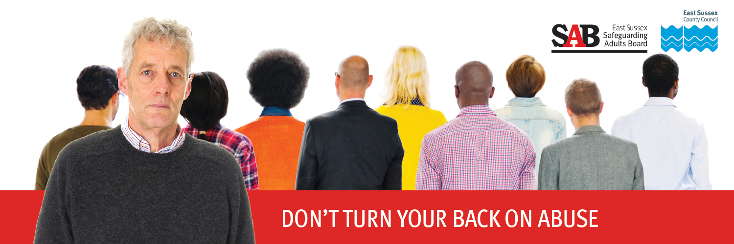
Version 1 May 2019

