7-minute briefing: Adult Death Protocol

Background

Situations in which an unexpected adult death takes place and there is a suspicion, or it is known, that abuse or neglect contributed to that death is a complex arena for agencies to navigate. Learning from Safeguarding Adults Reviews (SARs) has highlighted that often inter-agency systems have not been best equipped to respond to these deaths in a timely and collaborative way. A SAR known as ‘Adult B’ published in East Sussex (February 2020) made a recommendation to review existing arrangements for investigating unexpected adult deaths, where abuse or neglect is suspected or known to be a factor in the death, drawing upon existing legal mandates and the current Child Death Review process.

Although this recommendation was borne out of an East Sussex SAR, the need for the adult death protocol to be developed on a Sussex-wide basis was clear from the outset. The three Sussex Safeguarding Adults Boards (SABs) have worked with Sussex Police, local authorities, NHS Sussex, and a range of partners to develop this multi-agency protocol to address this important area.

The aim and purpose

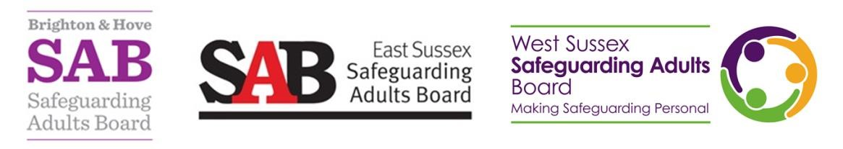
The adult death protocol does not replace or supersede any existing internal policies or procedures of partner agencies. The protocol has been developed with the aim of establishing a rapid, co-ordinated multi-agency response in situations where abuse or neglect by a third party is suspected to have been a contributory factor in someone’s death in order to ensure any criminal investigations and all other necessary actions are undertaken in a timely and efficient manner.

This protocol is based on existing legal mandates and should be used in conjunction with the Sussex Adult Policy and Procedures and the Sussex Information Sharing Guide and Protocol.
It will support in developing clarity and consistency across agencies with effective information sharing leading to improved outcomes in investigating unexpected adult deaths involving abuse or neglect.

When will the protocol apply?

The adult death protocol should only be used in relation to the following criteria:

- An adult dies in unexpected or unnatural circumstances, and;
- There is suspicion, or it is known, that they suffered from recent abuse or neglect or that it was a contributary factor in their death, and
- the abuse or neglect is believed to have been caused by a third party.

It will not apply in any situation involving a suspected homicide, where the homicide investigation and Domestic Homicide Review process takes precedence.

How do you make a referral?

Any agency or professional can make a referral for the adult death protocol, in situations in which they have been working with an adult who has died and abuse or neglect by a third party may have been a direct contributory factor.

- If the deceased is still at the location of their death, then contact should be made with the Sussex Police Contact Centre on 101 with details of the adult and how their death meets the criteria for the adult death protocol. Police will undertake an initial triage to identify if the criteria are met. These details will be passed onto first line police responders, who will visit the location of the body.
- Where the deceased is no longer at the location of their death, but information has come to light after their death, or they have subsequently died and the criteria for the adult death protocol are met a referral form should be completed. Complete the ADP Referral Form as soon as practicable and email to the relevant Police Multi-Agency Safeguarding Hub (MASH) listed on the form.

The process

The police will lead on reviewing and triaging any information to confirm whether the adult death protocol should be used. If the criteria are met the MASH will set up an Initial Joint Agency Meeting (IJAM) within 24 hours, The IJAM is a crucial step within the protocol to ensure the effective coordination between relevant agencies involved. The IJAM will be chaired by the MASH Detective Inspector and will be attended by senior representatives from the three statutory partners of the SABs (Police, NHS Sussex, and Local Authority) as well as any other key agencies who were involved in supporting the adult. Wherever possible the IAJM should take place within 24 hours of the death, with intelligence gathering taking place beforehand to enable essential information to be shared at the meeting.

For m
ore information on this briefing, contact:

•

West Sussex Safeguarding Adults Board:

safeguardingadultsboard@westsussex.gov.uk

•

East Sussex Safeguarding Adults Board:

ESSAB.contact@eastsussex.gov.uk

•

Brighton & Hove Safeguarding Adults Board:

SAB@brighton
-
hove.gov.uk

The core objectives of the IJAM are to ensure rapid risk assessment and information sharing, confirm who will be the lead agency, consider any other relevant enquiry of investigatory processes and agree a multi-agency action plan with timescales. There will also be consideration of the person’s family and how they should be involved and kept informed.

What happens next?

Agencies will progress identified actions from the IJAM with oversight being provided by the lead agency. If necessary, a follow-up meeting will be arranged and chaired by the lead agency within 6 weeks of the IJAM to ensure that actions are reviewed and to consider any learning from the case. This will involve not only consideration of case-specific learning but also broader systemic learning that may require further strategic actions.

Questions

- Are you clear of the criteria that means a case may need to use the adult death protocol?
- Do you know what action to take if the criteria are met?

